**Service 1: Expand Entity**

<https://help.sap.com/saphelp_gateway20sp08/helpdata/en/ca/c683e803494b77a2e1290b987556e2/content.htm>

**Requirement**

Considering a basic scenario where I am using  BAPI_PO_GETDETAIL which has multiple output tables and input is PO number

[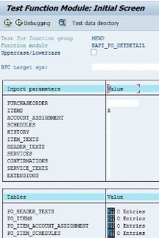](http://scn.sap.com/servlet/JiveServlet/showImage/38-110765-499505/bapipo.JPG)

Now we shall start with SAP Gateway

Create Project in SEGW

Create three entity types and Entity Sets with the properties in screen shot

Entity Type-1- Header

Entity Type-2- Item

Entity Type-3- Schedule

[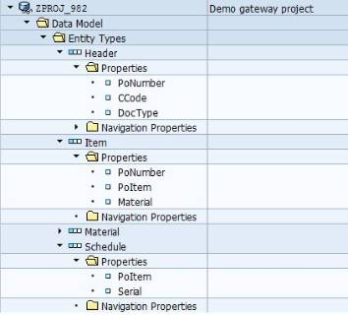](http://scn.sap.com/servlet/JiveServlet/showImage/38-110765-499623/po1.JPG)

Entity Set-1- HeaderSet

Entity Set-2- ItemSet

Entity Set-3- ScheduleSet

[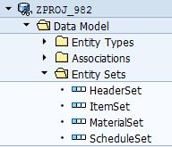](http://scn.sap.com/servlet/JiveServlet/showImage/38-110765-499624/po2.JPG)

Create Association:

Right click on association -> Create.

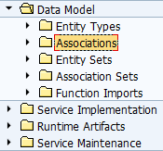

Enter the association name and fill in principle and dependent entity properties.

Check the check box ‘Create relation navigation property under principal entity’ and enter the navigation property name.

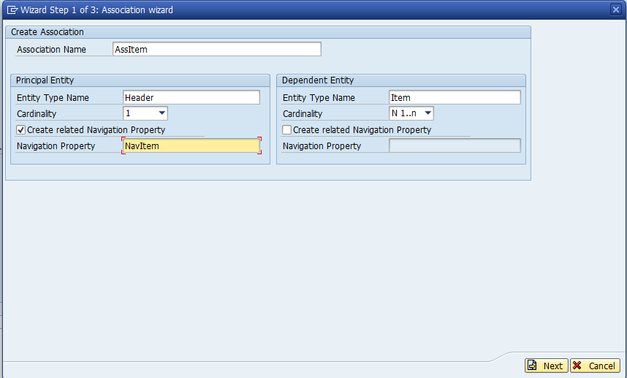

Enter the relation between two entities( Note that this is not mandatory).  
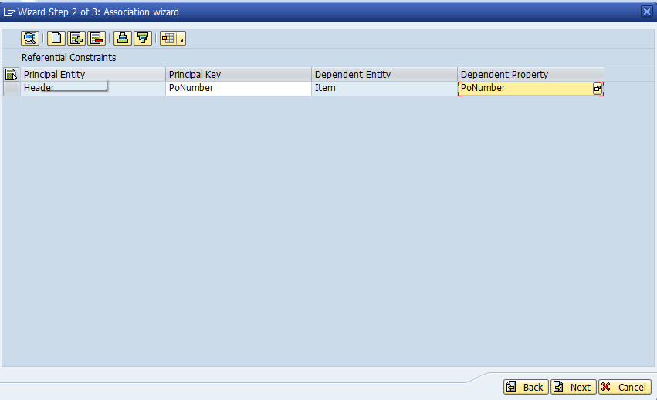

Similarly create AssSchedule without key mapping as those two entities don’t have keys (Don’t forget to enter navigation property unders header as this is important for the principal entity to navigate to dependent entity).

Association-1 -  AssItem (With key fields mapping)

Association-2 -  AssSchedule (Without key fields mapping)

[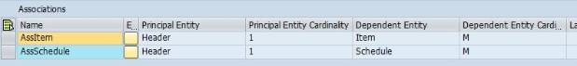](http://scn.sap.com/servlet/JiveServlet/showImage/38-110765-499637/po3.JPG)

Let’s generate runtime artifacts. Click on generate runtime objects button. It will display pop-up. Keep the default class names as-is and click on enter button.

Once generation is successful, you will get 4 classes. 2 for Data provider and 2 for Model provider.

[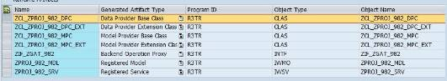](http://scn.sap.com/servlet/JiveServlet/showImage/38-110765-499639/po5.JPG)

We have to Redefine the method/IWBEP/IF_MGW_APPL_SRV_RUNTIME~GET_EXPANDED_ENTITYSET

**[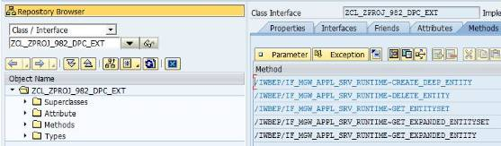](http://scn.sap.com/servlet/JiveServlet/showImage/38-110765-499664/po6.JPG)**

Code Snippet

METHOD /iwbep/if_mgw_appl_srv_runtime~get_expanded_entityset.

*-------------------------------------------------------------------------*

*             Deep Structure

*-------------------------------------------------------------------------*

   DATA:  BEGIN OF ls_order_items.

   INCLUDE       TYPE zcl_zproj_982_mpc=>ts_header.

   DATA: navitem       TYPE STANDARD TABLE OF zcl_zproj_982_mpc=>ts_item WITH DEFAULT KEY.

   DATA: navschedule   TYPE STANDARD TABLE OF zcl_zproj_982_mpc=>ts_schedule WITH DEFAULT KEY,

        END OF ls_order_items,

        ls_item1       TYPE zcl_zproj_982_mpc=>ts_item,

        ls_schedle1    TYPE zcl_zproj_982_mpc=>ts_schedule.

*-------------------------------------------------------------------------*

*             Data Declarations

*-------------------------------------------------------------------------*

   DATA :   ls_item                    TYPE zcl_zproj_982_mpc_ext=>ts_item,

            lt_item                    TYPE TABLE OF zcl_zproj_982_mpc_ext=>ts_item,

            ls_sch                     TYPE zcl_zproj_982_mpc_ext=>ts_schedule,

            lt_sch                     TYPE TABLE OF zcl_zproj_982_mpc_ext=>ts_schedule,

            ls_header                  TYPE zcl_zproj_982_mpc_ext=>ty_header,

            lthead                     TYPE STANDARD TABLE OF bapiekkol,

            lshead                     TYPE bapiekkol,

            lsitem                     TYPE bapiekpo,

            ltitem                     TYPE STANDARD TABLE OF bapiekpo,

            lv_filter_str              TYPE string,

            lt_filter_select_options   TYPE /iwbep/t_mgw_select_option,

            ls_filter                  TYPE /iwbep/s_mgw_select_option,

            ls_filter_range            TYPE /iwbep/s_cod_select_option,

            ls_expanded_clause1        LIKE LINE OF           et_expanded_tech_clauses,

            ls_expanded_clause2        LIKE LINE OF           et_expanded_tech_clauses,

            lv_ebeln                   TYPE ebeln,

**lt_order_items             LIKE TABLE OF ls_order_items,**

            ltsch                      TYPE STANDARD TABLE OF bapieket,

            lssch                      TYPE bapieket.

*-------------------------------------------------------------------------*

*             Entity Set - HeaderSet

*-------------------------------------------------------------------------*

   CASE iv_entity_set_name.

     WHEN 'HeaderSet'.

       LOOP AT it_filter_select_options INTO ls_filter.

         LOOP AT ls_filter-select_options INTO ls_filter_range.

           TRANSLATE ls_filter-property TO UPPER CASE.

           CASE ls_filter-property.

             WHEN 'PONUMBER'.

               lv_ebeln = ls_filter_range-low.

             WHEN OTHERS.

               " Log message in the application log

               me->/iwbep/if_sb_dpc_comm_services~log_message(

                 EXPORTING

                   iv_msg_type   = 'E'

                   iv_msg_id     = '/IWBEP/MC_SB_DPC_ADM'

                   iv_msg_number = 020

                   iv_msg_v1     = ls_filter-property ).

               " Raise Exception

               RAISE EXCEPTION TYPE /iwbep/cx_mgw_tech_exception

                 EXPORTING

                   textid = /iwbep/cx_mgw_tech_exception=>internal_error.

           ENDCASE.

         ENDLOOP.

       ENDLOOP.

*-------------------------------------------------------------------------*

*             Call Method-BAPI_PO_GETDETAIL

*-------------------------------------------------------------------------*

       CALL FUNCTION 'BAPI_PO_GETDETAIL'

         EXPORTING

           purchaseorder     = lv_ebeln

           items             = 'X'

           schedules         = 'X'

         IMPORTING

           po_header         = lshead

*         PO_ADDRESS        =

         TABLES

*         PO_HEADER_TEXTS   =

           po_items          = ltitem

           po_item_schedules = ltsch.

*-------------------------------------------------------------------------*

*             Fill Header Values to Deep Structure

*-------------------------------------------------------------------------*

       ls_order_items-ponumber = lshead-po_number.

       ls_order_items-ccode = lshead-co_code.

       ls_order_items-doctype = lshead-doc_type.

*-------------------------------------------------------------------------*

*             Fill Item values to Deep Structure

*-------------------------------------------------------------------------*

       LOOP AT ltitem INTO lsitem.

         CLEAR ls_item1.

         ls_item1-ponumber = lsitem-po_number.

         CALL FUNCTION 'CONVERSION_EXIT_ALPHA_OUTPUT'

           EXPORTING

             input  = ls_item1-ponumber

           IMPORTING

             output = ls_item1-ponumber.

         ls_item1-poitem = lsitem-po_item.

         ls_item1-material = lsitem-material.

         APPEND ls_item1 TO ls_order_items-navitem.

       ENDLOOP.

*-------------------------------------------------------------------------*

*             Fill Schedule values to Deep Strcture

*-------------------------------------------------------------------------*

       LOOP AT ltsch INTO lssch.

         CLEAR ls_item1.

*        ls_item1-ponumber = lsitem-po_number.

         ls_schedle1-poitem = lssch-po_item.

         ls_schedle1-serial = lssch-serial_no.

         APPEND ls_schedle1 TO ls_order_items-navschedule.

       ENDLOOP.

*-------------------------------------------------------------------------*

*             Assign the Navigation Proprties name to Expanded Tech clauses

*-------------------------------------------------------------------------*

       ls_expanded_clause1  = 'NAVITEM'.

       ls_expanded_clause2  = 'NAVSCHEDULE'.

       APPEND ls_expanded_clause1 TO et_expanded_tech_clauses.

       APPEND ls_expanded_clause2 TO et_expanded_tech_clauses.

*-------------------------------------------------------------------------*

*             Append Deep Strcture Values to Final Internal Table

*-------------------------------------------------------------------------*

       APPEND ls_order_items TO lt_order_items.

*-------------------------------------------------------------------------*

*             Send back Response to Consumer

*-------------------------------------------------------------------------*

       copy_data_to_ref(

         EXPORTING

           is_data = lt_order_items

         CHANGING

           cr_data = er_entityset ).

     WHEN OTHERS.

   ENDCASE.

ENDMETHOD.

Coding Part Done....Let’s move to Testing http://scn.sap.com/1273/images/emoticons/happy.gif

Test Case 1:

URI : /sap/opu/odata/sap/ZPROJ_982_SRV/HeaderSet?$filter=PoNumber eq '4500000163'&$expand=NavItem

**[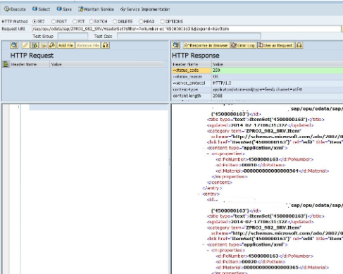](http://scn.sap.com/servlet/JiveServlet/showImage/38-110765-499665/po9.png)**

Test Case 2:

URI : /sap/opu/odata/sap/ZPROJ_982_SRV/HeaderSet?$filter=PoNumber eq '4500000163'&$expand=NavItem,NavSchedule

[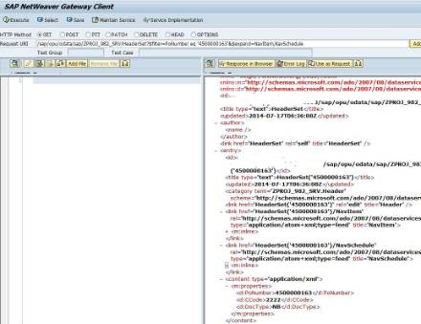](http://scn.sap.com/servlet/JiveServlet/showImage/38-110765-499682/po8.JPG)

For Expand Entity:-

From the modeling point of view there won’t be any changes

but in DPC we need to Redefine the method /iwbep/if_mgw_appl_srv_runtime~get_expanded_entity.

Also there would be a small change in Code, Like Below the change is get_expanded_entity is a single entity i.e. nothing but a single purchase order so you need to pass structure to Copy_data_to_ref method ( ls_order_items).

*-------------------------------------------------------------------------*

*             Deep Structure

*-------------------------------------------------------------------------*

   DATA:  BEGIN OF ls_order_items.

   INCLUDE       TYPE zcl_zproj_982_mpc=>ts_header.

   DATA: navitem       TYPE STANDARD TABLE OF zcl_zproj_982_mpc=>ts_item WITH DEFAULT KEY.

   DATA: navschedule   TYPE STANDARD TABLE OF zcl_zproj_982_mpc=>ts_schedule WITH DEFAULT KEY,

        END OF ls_order_items,

        ls_item1       TYPE zcl_zproj_982_mpc=>ts_item,

        ls_schedle1    TYPE zcl_zproj_982_mpc=>ts_schedule.

       copy_data_to_ref(

         EXPORTING

           is_data = **ls_order_items**

         CHANGING

           cr_data = **er_entity** ).